**Logistic Model Performance Evaluation for Liver Patients Data**

**Background Information:**

**(1) Patients** Suffering from Liver disease have been continuously increasing because of excessive consumption of alcohol, inhale of harmful gases, intake of contaminated food and drugs.

Problems with liver patients are not easily discovered in an early stage, as the liver will be functioning normally even when it is partially damaged.

Liver disease can be diagnosed by analyzing the levels of enzymes in the blood. An early diagnosis of liver problems will help to increase the patient’ s survival rate.

**(2) Data Set details:**



(Data Set Sample)

The data set contains 416 liver patient records and 167 non-liver patients. Total is 583 record.

The data set has a total of 11 attributes. Out of which 10 are Independent attributes and 1 is the Target attribute.

1. **Attributes details**

1. Age: Age of the patient   
2. Gender: Gender of the patient   
3. TB: Total Bilirubin   
4. DB: Direct Bilirubin   
5. Alkphos: Alkaline Phosphotase   
6. Sgpt: Alamine Aminotransferase   
7. Sgot: Aspartate Aminotransferase   
8. TP: Total Protiens   
9. ALB: Albumin   
10. A/G: Ratio Albumin and Globulin Ratio   
11. Selector field used to split the data into two sets (labeled by the experts) ( 1 - indicates liver patients, 2 - indicates non liver patients)

**(4) Data Division:**

Training data set is used to develop the model. 478 records are used.

Testing data used to evaluate the model developed using the Training data set. 105 records are used.

**Investigation:**

**1. Data clean:**

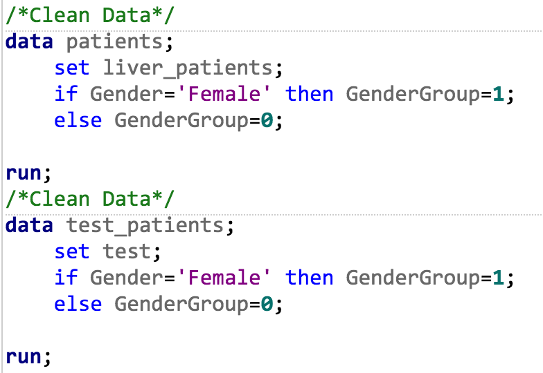

Change ‘Female’ to 1 and ‘Male’ to 0. And build a new column, named GenderGroup.

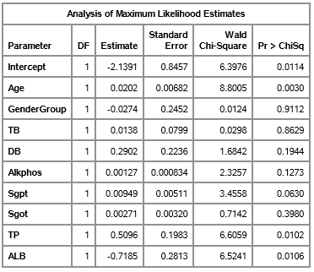

**2. Logistic Model:**

logit(p(liver_patient)) = log(p/1-p)

=-2.1391 + 0.0202*Age - 0.0274*Gender + 0.0138*TB + 0.2902*DB + 0.00127*Alkphos + 0.00949*Sgpt + 0.00271*Sgot + 0.5096*TP - 0.7185*ALB; #Gender == GenderGroup

The formula for liver patient probability: p = exp(logit)/(exp(logit) + 1)

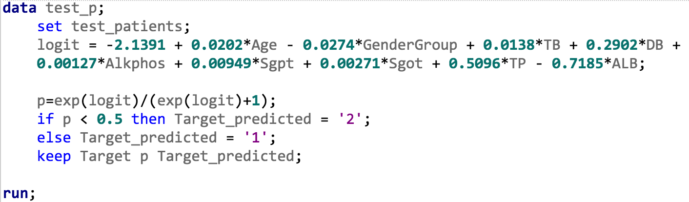

Substitute logic formula into ‘Testing Data Set’, if threshold p less than 0.5, the guy predicted to be the liver patient, else he or she is non liver patient. But from the table of part of sample result ‘test_p’,

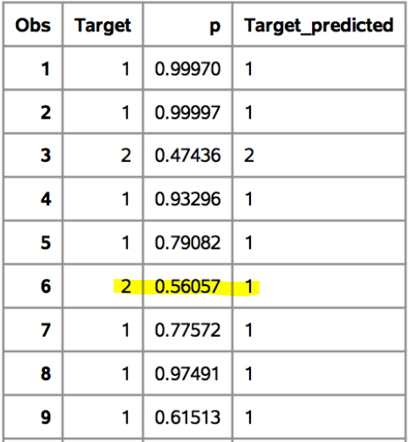

(test_p result table)

I find, people who is non liver patient predicted to be the liver patient.

**3. Evaluation**

In order to evaluate this logistic regression:

**The first step** is build a ‘Confusion Matrix’. A **confusion matrix** is a table that is often used to describe the performance of a classification model (or "classifier") on a set of test data for which the true values are known.

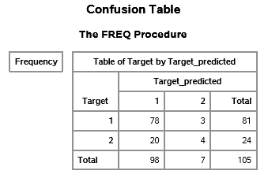

(confusion matrix)

**I. Accuracy VS Error Rate:**

Accuracy = true positive and true negative / total cases = ( 78 + 4 ) / 105 = 78.1%

Error Rate = false positive and false negative / total cases = (20 + 3) / 105 = 21.9%

**II. Recall VS PV+:**

Recall (True Positive Rate/ Sensitivity) = true positive/ total actual positive = 78 / 81 = 96.30% (TPR)

Precision(Positive Predicted Value , PV+) = true positive / total predicted positive = 78 / 98 = 79.59%

**III Specificity VS PV-:**

Specificity(True Negative Rate) = true negative / total actual negative = 4 / 24 = 16.67%

Negative Predicted Value(PV-) = true negative / total predicted negative = 4 / 7 = 57.14%

All of these data can deliver from **proc freq procedure**.

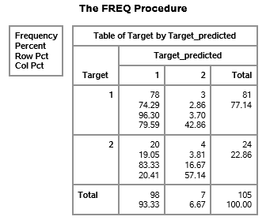

**IV F1-measure:**

F1-measure = 2*true positive / 2*true positive + negative positive +actual negative = (2 * 78) / (78 + 98 + 20) = 79.59%

**Second Step: ROC**

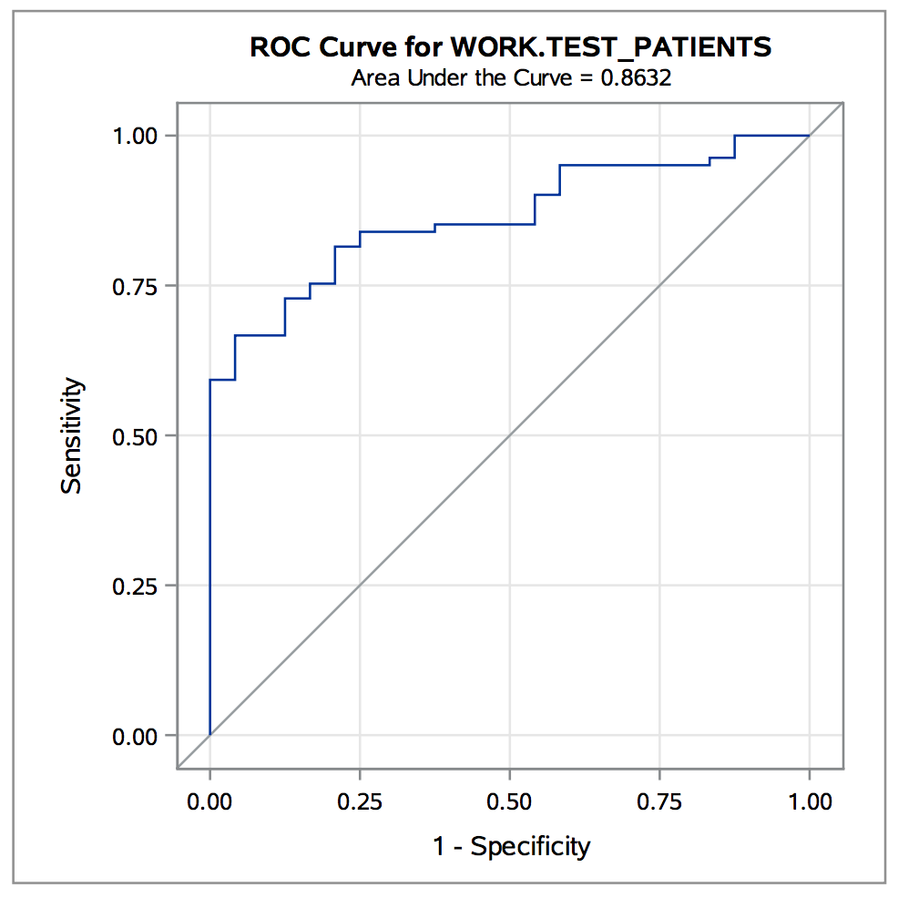

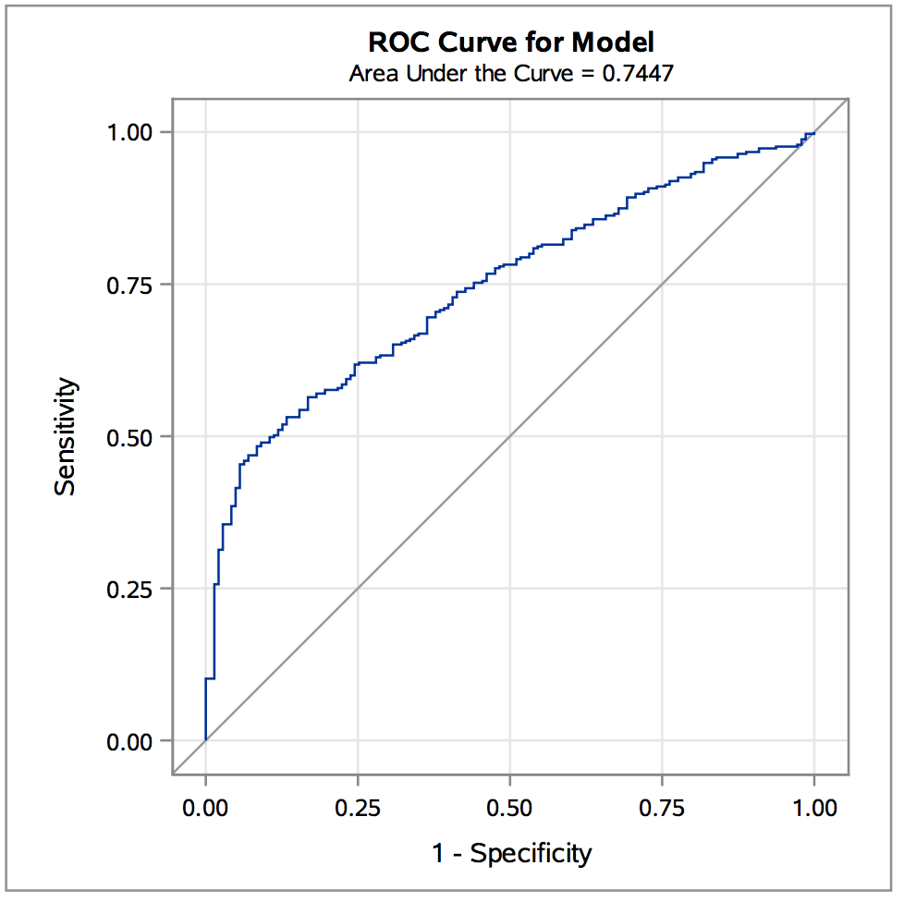

Compare to the AUC equals to 0.7447 in train data, the test data’s AUC is 0.8632, bigger than train data’s. It shows this logistic model would be considered to be ‘good’ at classifying people is liver patient or not.